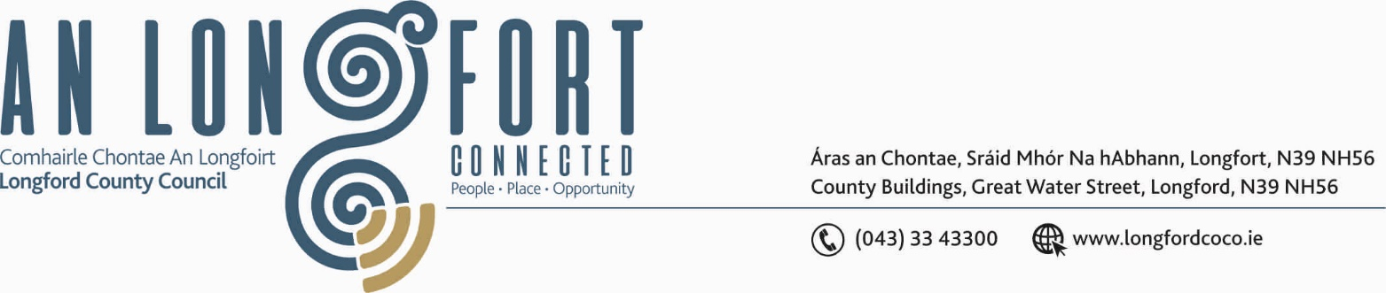

LONGFORD MUNICIPAL DISTRICT

21st February 2019.

To: Each Member of Longford Municipal District.

Dear Member,

You are requested to attend Meeting of Longford Municipal District to be held in the Council Chamber, Town Hall, Market Square, Longford, on Wednesday, 27th February 2019 at
4.00 p.m. to transact business, as set out on the Agenda hereunder.

Yours sincerely,


_______________
Anne Lee,
Meetings Administrator.

AGENDA

Prayer before meeting.

- Confirmation of Minutes of Longford Municipal District Meetings held on the
23rd January 2019 – copy enclosed.

- Matters arising from Minutes.

- Management Report - to follow.

- Update on CCTV.

- Consideration and adoption of Draft Municipal District Report for inclusion in
Longford County Council 2018 Annual Report – enclosed.

6 Update on Salt Barn at Park Road.

7. A.O.B.

